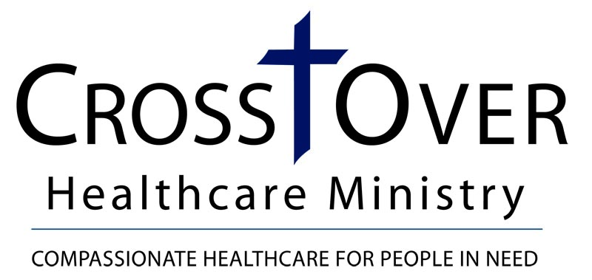
IRA Gift Form Letter
(Request from Plan Owner to Plan Administrator for a Charitable Distribution from an Individual Retirement Account)

Date

Name of Plan Trustee/Administrator
Street Address
City, State Zip

Dear Sir or Madam:

Please accept this letter as my request to make a direct charitable distribution from my Individual Retirement Account # _______________ as provided by the Protecting Americans from Tax Hikes Act of 2015, Revenue Code of 1986, as amended.

Please issue a check in the amount of $ _____________ payable to CrossOver Healthcare Ministry and mail to the address below:
CrossOver Healthcare Ministry
Development Office
8600 Quioccasin Road, Suite 101
Richmond, VA 23229

In your transmittal to CrossOver Healthcare Ministry, please note my name and address as the donor of record for this transfer and copy me on the transmittal. If you have any questions, or need to contact me, I can be reached at (your telephone number).

Thank you.

Sincerely,

Plan Owner/Donor
Address
City, ST Zipcode

