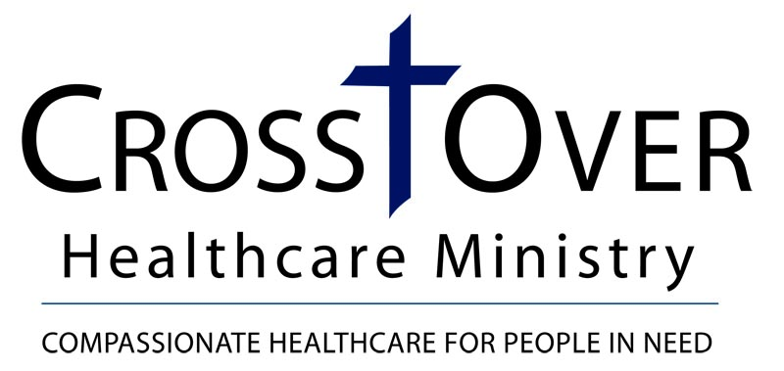
Qualified Charitable Distribution (IRA) Gift Form Letter
(Notification of Qualified Charitable Distribution letter from Plan Owner to CrossOver Healthcare Ministry)

Date

CrossOver Healthcare Ministry
Development Office
8600 Quioccasin Road, Suite 101
Richmond, VA 23229

Dear CrossOver Healthcare Ministry Development Office,

It is my pleasure to inform you that I have requested a qualified charitable distribution from my Individual Retirement Account (IRA) payable to CrossOver Healthcare Ministry in the amount of $_____________ from my plan trustee/administrator, (name of plan trustee/administrator).

Please designate my distribution to ____________________________. (OR) My distribution is undesignated and may be used for CrossOver Healthcare Ministry’s greatest need.

It is my intent to comply with the requirements of the Protecting Americans from Tax Hikes Act of 2015 of the Internal Revenue Code of 1986, as amended, in connection with this gift.

Accordingly, upon your receipt of payment from my plan trustee/administrator, please send me written acknowledgement that states the amount of my gift, and that no goods or services were transferred to me by CrossOver Healthcare Ministry in consideration for this gift.

If you have any questions, or need to contact me, I can be reached at (your telephone number).

Sincerely,

Donor Name
Address
City, ST Zipcode

